**MAIN TITLE ARIAL 22 PT BOLD**

**SubTitle Arial 20 pt Bold**

**Publication No. FHWA-CFL/TD-14-xxx October 2014**



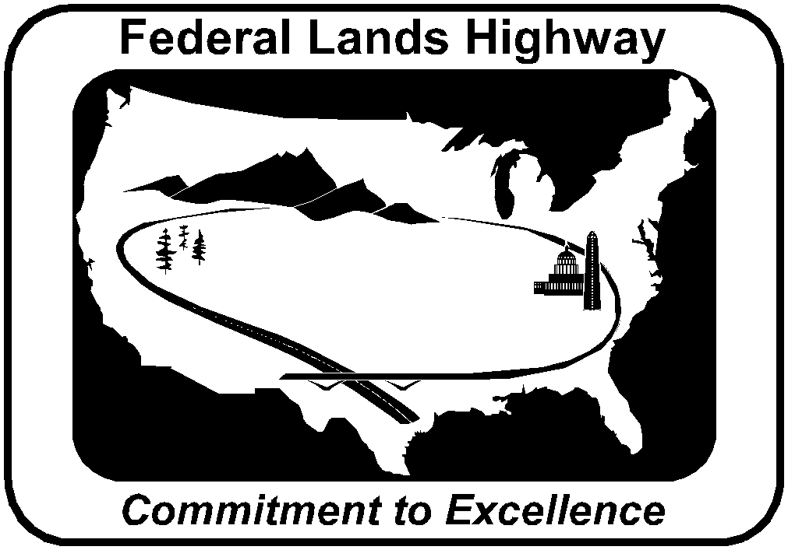

**Central Federal Lands Highway Division**

**12300 West Dakota Avenue**

**Lakewood, CO 80228**



**FOREWORD**

The Federal Lands Highway (FLH) promotes development and deployment of applied research and technology applicable to solving transportation related issues on Federal Lands. The FLH provides technology delivery, innovative solutions, recommended best practices, and related information and knowledge sharing to Federal agencies, Tribal governments, and other offices within the FHWA.

The objective of this study was to produce a prime and tack coat publication that would guide project development and field personnel in making decisions on how to use, when to keep, and when to eliminate prime and tack coats [Your specific information here].

The study included a [Your specific information here] literature search on prime and tack coats, a review of environmental considerations for prime and tack coat usage and a phone survey to determine the current practice of state DOTs from the CFLHD region. Recommendations for improving CFLHD’s specifications were made. Based on the information collected, this guideline was produced.

The contributions and cooperation of the CFLHD personnel is gratefully acknowledged.

**NOTICE**

This document is disseminated under the sponsorship of the U.S. Department of Transportation in the interest of information exchange. The U.S. Government assumes no liability for the use of the information contained in this document. This report does not constitute a standard, specification, or regulation.

The U.S. Government does not endorse products or manufacturers. Trademarks or manufacturers' names appear in this report only because they are considered essential to the objective of the document.

**QUALITY ASSURANCE STATEMENT**

The Federal Highway Administration (FHWA) provides high-quality information to serve Government, industry, and the public in a manner that promotes public understanding. Standards and policies are used to ensure and maximize the quality, objectivity, utility, and integrity of its information. FHWA periodically reviews quality issues and adjusts its programs and processes to ensure continuous quality improvement.

**Technical Report Documentation Page**

|  |  |  |  |  |  |  |
| --- | --- | --- | --- | --- | --- | --- |
| 1. Report No.  FHWA-CFL/TD-0x-00x | 2. Government Accession No. | | | 3. Recipient's Catalog No. | | |
| 4. Title and Subtitle  *Times New Roman 10 pt Italicized* | | | | 5. Report Date  October 2014 | | |
| 6. Performing Organization Code | | |
| 7. Author(s) | | | | 8. Performing Organization Report No. | | |
| 9. Performing Organization Name and Address  Texas A&M Transportation Institute  3135 TAMU  College Station, Texas 77843-3135 | | | | 10. Work Unit No. (TRAIS) | | |
| 11. Contract or Grant No. | | |
| 12. Sponsoring Agency Name and Address  Federal Highway Administration  Central Federal Lands Highway Division  12300 W. Dakota Avenue, Suite 210  Lakewood, CO 80228 | | | | 13. Type of Report and Period Covered | | |
| 14. Sponsoring Agency Code  HFTS-16.4 | | |
| 15. Supplementary Notes  COTR: First & Last name, FHWA CFLHD; Advisory Panel Members: List First & last names. This project  was funded under the FHWA Federal Lands Highway Technology Deployment Initiatives and Partnership  Program (TDIPP). Or the Coordinated Technology Implementation Program (CTIP). | | | | | | |
| 16. Abstract  Times New Roman 10 pt font. | | | | | | |
| 17. Key Words  **TIMES NEW ROMAN 12 PT, ALL CAPS,**  **BOLD,** | | | 18. Distribution Statement  No restriction. This document is available to the  public from the sponsoring agency at the website  http://www.cflhd.gov. | | | |
| 19. Security Classif. (of this report)  Unclassified | | 20. Security Classif. (of this page)  Unclassified | | | 21. No. of Pages  22 | 22. Price |

**Form DOT F 1700.7 (8-72) Reproduction of completed page authorized**

|  |  |  |  |  |  |  |  |
| --- | --- | --- | --- | --- | --- | --- | --- |
| **SI* (MODERN METRIC) CONVERSION FACTORS** | | | | | | | |
| **APPROXIMATE CONVERSIONS TO SI UNITS** | | | | | | | |
| **Symbol** | **When You Know** | | **Multiply By** | **To Find** | | | **Symbol** |
| **LENGTH** | | | | | | | |
| in | inches | | 25.4 | millimeters | | | mm |
| ft | feet | | 0.305 | meters | | | m |
| yd | yards | | 0.914 | meters | | | m |
| mi | miles | | 1.61 | kilometers | | | km |
| **AREA** | | | | | | | |
| in2 | square inches | | 645.2 | square millimeters | | | mm2 |
| ft2 | square feet | | 0.093 | square meters | | | m2 |
| yd2 | square yard | | 0.836 | square meters | | | m2 |
| ac | acres | | 0.405 | hectares | | | ha |
| mi2 | square miles | | 2.59 | square kilometers | | | km2 |
| **VOLUME** | | | | | | | |
| fl oz | fluid ounces | | 29.57 | milliliters | | | mL |
| gal | gallons | | 3.785 | liters | | | L |
| ft3 | cubic feet | | 0.028 | cubic meters | | | m3 |
| yd3 | cubic yards | | 0.765 | cubic meters | | | m3 |
| NOTE: volumes greater than 1000 L shall be shown in m3 | | | | | | | |
| **MASS** | | | | | | | |
| oz | ounces | | 28.35 | grams | | | g |
| lb | pounds | | 0.454 | kilograms | | | kg |
| T | short tons (2000 lb) | | 0.907 | megagrams (or "metric ton") | | | Mg (or "t") |
| **TEMPERATURE (exact degrees)** | | | | | | | |
| °F | Fahrenheit | | 5 (F-32)/9 | Celsius | | | °C |
|  | |  | or (F-32)/1.8 | |  |  | | |
| **ILLUMINATION** | | | | | | | |
| fc | foot-candles | | 10.76 | lux | | | lx |
| fl | foot-Lamberts | | 3.426 | candela/m2 | | | cd/m2 |
| **FORCE and PRESSURE or STRESS** | | | | | | | |
| lbf | poundforce | | 4.45 | newtons | | | N |
| lbf/in2 | poundforce per square inch | | 6.89 | kilopascals | | | kPa |
| **APPROXIMATE CONVERSIONS FROM SI UNITS** | | | | | | | |
| **Symbol** | **When You Know** | | **Multiply By** | **To Find** | | | **Symbol** |
| **LENGTH** | | | | | | | |
| mm | millimeters | | 0.039 | inches | | | in |
| m | meters | | 3.28 | feet | | | ft |
| m | meters | | 1.09 | yards | | | yd |
| km | kilometers | | 0.621 | miles | | | mi |
| **AREA** | | | | | | | |
| mm2 | square millimeters | | 0.0016 | square inches | | | in2 |
| m2 | square meters | | 10.764 | square feet | | | ft2 |
| m2 | square meters | | 1.195 | square yards | | | yd2 |
| ha | hectares | | 2.47 | acres | | | ac |
| km2 | square kilometers | | 0.386 | square miles | | | mi2 |
| **VOLUME** | | | | | | | |
| mL | milliliters | | 0.034 | fluid ounces | | | fl oz |
| L | liters | | 0.264 | gallons | | | gal |
| m3 | cubic meters | | 35.314 | cubic feet | | | ft3 |
| m3 | cubic meters | | 1.307 | cubic yards | | | yd3 |
| **MASS** | | | | | | | |
| g | grams | | 0.035 | ounces | | | oz |
| kg | kilograms | | 2.202 | pounds | | | lb |
| Mg (or "t") | megagrams (or "metric ton") | | 1.103 | short tons (2000 lb) | | | T |
| **TEMPERATURE (exact degrees)** | | | | | | | |
| °C | Celsius | | 1.8C+32 | Fahrenheit | | | °F |
| **ILLUMINATION** | | | | | | | |
| lx | lux | | 0.0929 | foot-candles | | | fc |
| cd/m2 | candela/m2 | | 0.2919 | foot-Lamberts | | | fl |
| **FORCE and PRESSURE or STRESS** | | | | | | | |
| N | newtons | | 0.225 | poundforce | | | lbf |
| kPa | kilopascals | | 0.145 | poundforce per square inch | | | lbf/in2 |

*SI is the symbol for the International System of Units. Appropriate rounding should be made to comply with Section 4 of ASTM E380.

(Revised March 2003)

**Table of Contents**

List of Figures iii

List of Tables iv

List of Abbreviations and Symbols v

Acknowledgments vi

Executive Summary 1

Chapter 1. Introduction 3

Background 3

Chapter 2. 5

Chapter . Conclusions 7

References 9

Bibliography 11

Appendix 13

# List of Figures

# List of Tables

# List of Abbreviations and Symbols

**Abbreviations**

**Symbols**

# Acknowledgments

This section is optional.

# Executive Summary

This section is optional.

# Chapter 1. Introduction

## Background

To change the header for each new chapter, be sure there is an Odd Section break between the chapters. Then open the header and turn off the Link to Previous. Then you can alter the next Chapter’s header without changing the previous one.

# Chapter 2.

# Chapter      . Conclusions

# References

References must be Endnotes. If you need help using endnotes, feel free to ask COM staff. Follow the *Chicago Manual of Style* format for the source listing (See. <http://www.chicagomanualofstyle.org/16/ch15/ch15_sec009.html> for examples).

# Bibliography

This section is optional. A bibliography contains sources used in the document that are not cited. A bibliography is alphabetized. This section may have to be added later since Word makes Endnotes occur at the end of the document.

# Appendix